A Deep Learning Based Paradigm in 3D Human Pose Detection and Estimationin Multi-View Videos

ECE445/ME470 Individual Progress Report

Fengkai Chen
Group 14
Project Advisor: Gaoang Wang
Course Instructor: Mark Butala
1.Introduction
1.1 Problem and Solution Overview
Human Pose estimation and reconstruction is a widely researched topic in the recent
decades. Its main idea is detecting location of people’s joints which form a skeleton, and to
estimate the posture and movement of human body. Estimating the pose of a human in 3D
given an image or a video has recently received significant attention from the scientific
community. The main reasons for this trend are the ever-increasing new range of applications
(e.g., human-robot interaction, gaming, sports performance analysis) which are driven by
current technological advances [1].
Although recent approaches have reported remarkable results in 3D pose estimation
from static images, it remains an unsolved problem in continues-time videos. This is because
the time-varying overlaps of human bodies in consecutive video frames impose several
challenges in detecting the joints from human bodies, which are not fully addressed by existing
methods.
The objective of this project is to propose a 3D Pose Estimation paradigm for video
setting via leveraging machine learning and optimization technique. In particular, we will first
use a Neural Network (NN) to detect the human body (pose) from the surroundings in video
clips captured by our multi-view camera system. The detected poses are indicated by a group of
boxes (bounding boxes). Then we apply multi-way matching algorithm to cluster the detected
2D poses in the resulting bounding boxes, and finally reconstruct the 3D pose associated to
each person.
The multi-way matching algorithm aims at finding 2D poses of the same person in a
group of videos clips captured by several cameras (our camera system). For example, there are
five people (labeled in 1 to 5) in the room, and we have three cameras shooting from different
directions. Then the multi-way matching algorithm matches the 2D pose of person 1 in video
from camera 1 to his 2D poses in videos from camera 2 and camera 3. The matched 2D poses of
3 person 1 are categorized by bounding boxes of a specific color (a color corresponds to a labeled person), and 2D poses inside the bounding boxes with same color will be cut-out from the video for 3D pose reconstruction. The 2D to 3D pose reconstruction is done by some well-developed approach such as 3D pictorial structure (3DPS) based model [2].
Figure 1.1 Diagram of 3D pose estimation
1.2 Personal Contribution
1.2.1 Achieved
For the first two weeks, I was working on setting up the environment for our 3D pose estimation. In the beginning, we tried to directly build the model on our own PC, but we cannot find required versions of some modules (tensorflow1.9.0, pytorch). Therefore, we installed ubuntu16.04, and try to transfer all our project from WIN10 to Linux.
The results turned out that Linux can support our needs, and I installed all required modules. We try to train our models on Campus dataset, but the current GPU(RTX 2060 6GB) do not have enough memory for training. Again, we transfer all our project to the HPC (high performance computer)
Figure 1.2 Runtime error we met
The GPU of HPC is Tesla V100 32GB, which has abundant memory for machine learning, and after some simple adjustment and set up, I successfully run out our first result. (Figure 1.3&1.4)
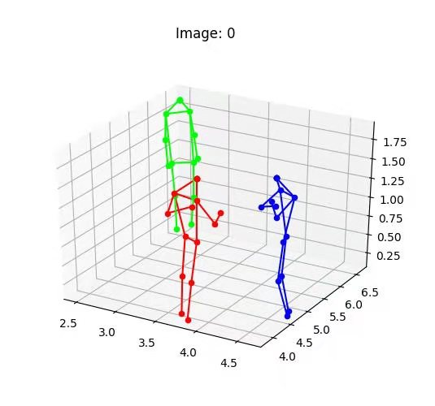
Figure 1.3 Visualized result of our 3D pose estimation
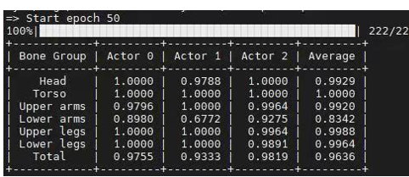
Figure 1.4 The accuracy of our result
1.2.2 In progress
I am currently working on the result analysis. For our result of first models, the overall performance is beyond our expectation. But as we can find in Figure 1.4, the accuracy of Lower arms, Actor 1 is on 0.6772, which is a relatively low score. After studied the result, we believe the low score at Actor 1 is caused by human overlapping. If we can modify our network, and train through time series, the error caused by overlapping can be significantly reduced.
1.2.3 Left to Do
For the following weeks, I need to record some videos for demonstration at ZJUI Campus. (Short videos,1-2 minutes). My teammates will modify the network, and we will perform a 3D pose estimation on our videos.

2.Design&Verification
Personal Design work: During designing, our group work together and all of us contribute to the design modules, here I will only list the design modules that I have relatively higher contribution.
2.1 Design
2.1.1 Camera Module
Camera module contains several cameras with different positions and projection angles
as the following figure shown. The camera system provides us a multi-frame real time video of
human movement, which will be used as raw data for subsequent software processing
Figure 2.1 Camera Module

2.1.1 2D Pose Detection Module
This 2D pose detection module serves to produce 2D locations of people in each view, and every detected human pose will be labeled with box, which is called “bounding box”. For example, in the figure below, a walking man is detected and marked with some joints to represent his pose. Our result will be a bit different from this figure because we use bounding box to label each human pose. Our approach will be using a Convolutional Neural Network (CNN) pretrained on MSCOCO [10] dataset for 2D pose detection in images to finish this task. As shown in the block diagram, our CNN consists of two sub networks: the GlobalNet estimates human limbs approximately and the RefineNet provides more detailed human joints on 2D poses. Both models are proposed in [14].
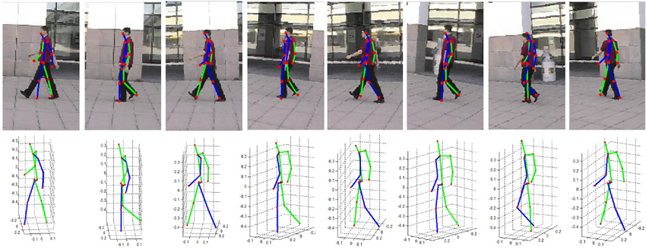
Figure 2.2 2D Pose Detection Module
2.2 Verification
2.2.1 MPJPE
Our visualized 3D pose estimation result and accuracy is shown in figure1.3&1.4, and our final test will also be in the similar form. The way we verify our test results is not only by looking at the visualized 3D pose, but also need to calculate the MPJPE to measure the average accuracy.
Suppose there are k people in the videos, each comprised of n joints. After processing, we can represent $i_{th} people^{'}s j_{th} joint with three features \hat{y_{i,j}}=\left(\hat{x}, \hat{y}, \hat{z}\right),$and we have the ground truth label $y_{i,j}=\left(x, y, z\right).$Then we can use Mean Per Joint Position Error (MPJPE) to validate the performance of our program. Per joint position error is the Euclidean distance between ground truth and prediction for a joint. The prediction error is $Err_{pred}=\frac{1}{k}\frac{1}{n}{\sum_{i=1}^{k}{\sum_{j=1}^{n}{\left\|\hat{y_{i,j}}- y_{i,j}\right\|}}}_{2}$.
Suppose there is only one person in the video, and we establish the coordinate system based on him, setting his pelvis as the origin. Suppose this person is comprised of 5 joints – pelvis, two feet and two hands. So we have $\hat{y_{1,1}}=\left(0,0,0\right), \hat{y_{1,2}}=\left(-0.2, 0, -1\right), \hat{y_{1,3}}=\left(0.2, 0, -1\right), \hat{y_{1,4}}=\left(-0.1, 0, 0.5\right), \hat{y_{1,5}}=\left(0.1, 0, 0.5\right).$And the estimation of our program is $y_{1,1}=\left(0,0,0.1\right), y_{1,2}=\left(-0.2,0,0\right), y_{1,3}=\left(0.2,0,-1\right), y_{1,4}=\left(-0.1,0,0.5\right), y_{1,5}=\left(0.1,0,0.5\right).$
$$Err_{pred}=\frac{1}{k}\frac{1}{n}{\sum_{i=1}^{k}{\sum_{j=1}^{n}{\left\|\hat{y_{i,j}}- y_{i,j}\right\|}}}_{2}=\frac{1}{5} \left(\sqrt{{\left(0-0.1\right)}^{2}}+\sqrt{{\left(-1-0\right)}^{2}}\right)=0.22$$

2.2.1 Our Test results and
Again, one should note the performance of some of our sub-moduel such as ResNet, naïve 3DPS has already been investigated and demonstrated in others work. We focus on the overall system performances. All testing up to now was conducted on campus HPC with 4 GeForce 3080Ti GPU, and the following testing results are credited to my other three teammates.
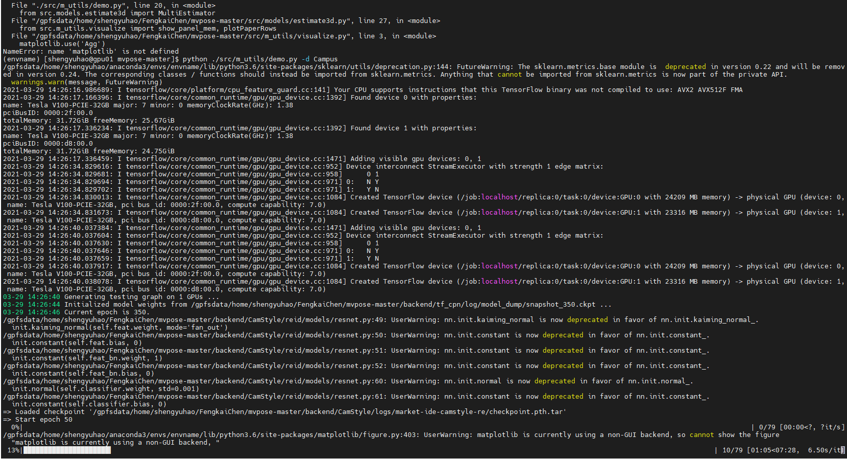
Figure 2.3 Code compiling in HPC
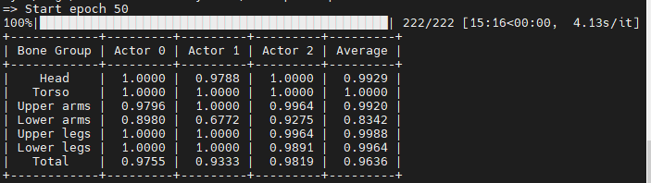
Figure 2.4 3D reconstruction accuracy
Figure 2.3 suggests that our network model has been successfully complied on campus HPC without bugs. Figure 2.4 gives the final 3D pose reconstruction accuracy after running the model/algorithm proposed in section 2.1 and 2.2, with a naïve 3DPS mentioned in section 2.3. The 3D pose reconstruction accuracy is defined as:
$$accuracy=\frac{1}{N}\sum_{n=1}^{N}{Γ_{n}}$$
$N$ denotes the total number 3D joints on an actor’s body, of and $Γ_{n}∈\{0,1\}$ is the indicator function defined as:
$$Γ_{n}=\left\{\begin{aligned}1, if \left\|s_{n}-s_{n}^{'}\right\|≤δ \\ 0, else\end{aligned}\right.$$
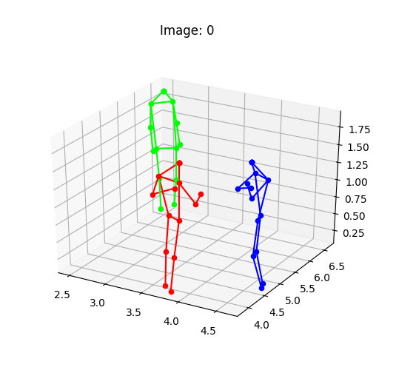
where $s_{n}∈R^{3}$denotes the predicted 3D position of joint $n$ and $s_{n}^{'}∈R^{3}$ is the actual 3D position of joint $n$. $δ$ is the threshold. All testing was on CMU data sets and $δ$ was set as 4.5. Reconstructed 3D pose is shown as follows.
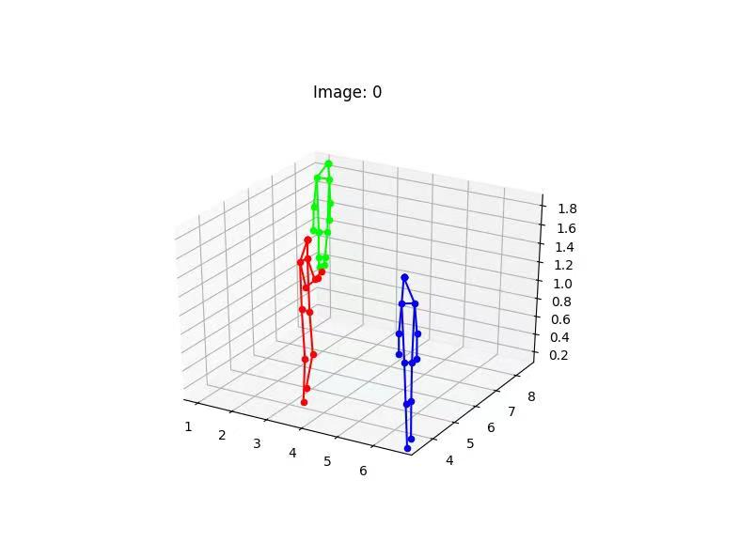

Figure 2.5 Selections of the reconstructed 3D poses
We found that in some reconstructed 3D pose such as the green pose right one in Figure 2.5 (or lower arms of Actor 1 in figure 2.4), part of the human body was missing. This may be due to unsatisfactory 2D posed detection affected by body overlapping. Adding recurrent layers to our network model to capture the temporal information between body movements may solves this problem.
3.Conclusion
3.1 Schedule

 | Fengkai Chen
03/01/21 | Study and read related paper
03/08/21 | Set up the environment on PC
03/15/21 | Use the provided model to perform 3D estimation on Image dataset
03/22/21 | Examine the first demo results,data dugmentation
03/29/21 | Trainning our model on video dataset.(CMU Panoptic)
04/05/21 | Run the model validation& test. Analyze the result analysis.
04/12/21 | Using webcam recorded/real-time videos to demo 3D estimation
04/19/21 | Try real-time videos under complex situation (Small object, overlap object) to test the robustness of our model
04/26/21 | Start with Final Report
05/03/21 | Prepare Final Presentation & Finish Final Report
Table 3.1 Time Schedule
3.1.1 Self-assessment
Our group evenly distribute the work for each member, and my individual work is just about ¼ of our entire work.
Currently I am just stick with the schedule, and if I continue to follow the schedule, we will be able to finish the project successfully before the demonstration.
3.2 Ethics&Safety
Our project has several potential safety and ethics concerns. The first concern is network intrusion. Currently we are using campus network to transmit our information and signals. However, every network has a possibility to be attacked, and this rule also applies to our campus network. This is against #7 and #9 of the IEEE Code of Ethics – “the people committing piracy are not properly crediting the work of others, and they could be injuring the copyright holders by sharing content without paying for it.” [4] Once the network is controlled, we may lose our control over the whole system, such that our core codes and algorithms may leak. Actually, we do not have a perfect plan for this. Our current solution is that use version control tools, like SVN and git, to store our codes and do not publish it before some sense of agreement is made.
The second concern is the private pictures/video disclosure. The disclosure violates the ACM code of Ethics, #1.6, “Therefore, a computing professional should become conversant in the various definitions and forms of privacy and should understand the rights and responsibilities associated with the collection and use of personal information.” [5] Due to the high volume of picture/videos used for network training, saving all data in our personal laptop is not recommended. For convenience in calling data, we plan to store our data on an online server, which may be cyber-attacked and cause data disclosure. To minimize such risk, we suggest shutting down network acceleration software such as Cisco AnyConnect Mobility Client and Express VPN when testing online algorithms.
With the following concerns are fully considered, we still want to make sure that the model will treat everyone equally. If we use a biased training dataset, like some dataset mostly containing videos/pictures of white people, the model may have worse effects on black, Asian and Hispanic people. If we use a training dataset that mostly involves men moving and acting, this model may have worse effects on women. All these violate the #8 of the IEEE Code of Ethics, “to treat fairly all persons and to not engage in acts of discrimination based on race, religion, gender, disability, age, national origin, sexual orientation, gender identity, or gender expression” [4]. To avoid such things, we will carefully choose our dataset, including the percentage of different races, genders, ages and other tags that may divide people into different groups, to ensure an unbiased development process.

References
[1] Sarafianos, Nikolaos & Boteanu, Bogdan & Ionescu, Bogdan & Kakadiaris, Ioannis. 3D Human Pose Estimation: A Review of the Literature and Analysis of Covariates, in Computer Vision and Image Understanding, 2016.

[2] V. Belagiannis, S. Amin, M. Andriluka, B. Schiele, N. Navab, and S. Ilic. 3d pictorial structures for multiple human pose estimation. In CVPR, 2014.

[3] J. Dong, W. Jiang, Q. Huang, H. Bao, and X. Zhou. Fast and robust multi-person 3d pose estimation from multiple views. In CVPR, 2019.

[4] CVSSP Research. Multi-Person 3D Pose Estimation and Tracking in Sports. Apr.17, 2019. [Online Video]. Available: https://www.youtube.com/watch?v=jLEv14GAcbs

[5] ieee.org, IEEE Code of Ethics, 2020. [Online].
Available: http://www.ieee.org/about/corporate/governance/p7-8.html[Accessed: 28- Feb- 2021].7

[6] ethics.acm.org, ACM Code of Ethics, 2020. [Online]. Available: https://ethics.acm.org. [Accessed: 28- Feb- 2021].7

[7] openaccess.org, 3D human pose estimation in video with temporal convolutions and semi-supervised training, 2020. [Online].

[8] Umar.Iqbal, Pavlo.Molchanov, Jan.Kautz, NVIDIA Research. Weakly-Supervised 3D Human Pose Learning via Multi-view Images in the Wild. In CVPR, 2020

[9] Fast Human Pose Detection Using Randomized Hierarchical Cascades of Rejectors - Scientific Figure on ResearchGate.

[10] T. Lin, M. Maire, S. Belongie, J. Hays, P. Perona, D. Ramanan, P. Doll´ar, and C. Zitnick. Microsoft coco: Common objects in context. In ECCV, 2014.
[11] Kocabas M, Karagoz S, Akbas E. Self-Supervised Learning of 3D Human Pose using Multi-view Geometry[J]. In CVPR, 2019.

[12] Joo, Hanbyul and Simon, et al. Panoptic Studio: A Massively Multiview System for Social
Interaction Capture, IEEE Transactions on Pattern Analysis and Machine Intelligence,2017

[13] V. Belagiannis, S. Amin, M. Andriluka, B. Schiele,N. Navab, and S. Ilic. 3d pictorial structures for multiple human pose estimation. In CVPR, 2014. 1, 2, 6, 7

[14] Y. Chen, Z. Wang, Y. Peng, Z. Zhang, G. Yu, and J. Sun. Cascaded pyramid network for multi-person pose estimation. In CVPR, 2018. 3, 6, 7

